**Bug Tracking System**

**Bug Tracking System** enables to detect the bugs. It not merely detects the bugs but provides the complete information regarding bugs detected.

Bug information includes the **bug id, bug name, bug priority, project name, bug location, bug type**.

This whole process continues until all the bugs are fixed in the application.

The bug report is mailed to the project manager and the developer as soon as the bug is identified. This makes that no error will go unfixed because of poor communication. It ensure that anyone who needs to know about a bug can learn of it soon after it is reported.

**Objectives of the Bug Tracking System**

The main objectives of the Bug Tracking System are:

1. Reporting the bugs in an application.
2. Managing bug life-cycle.
3. Manage effort to fix bugs.
4. Send mails to stakeholders.

### Bug States

**#1) New**: This is the first state of a defect in the Defect Life Cycle. When any new defect is found, it falls in a ‘New’ state, and validations and testing are performed on this defect in the later stages of the Defect Life Cycle.

**#2) Assigned:** In this stage, a newly created defect is assigned to the development team for working on the defect. This is assigned by the project lead or the manager of the testing team to a developer.

**#3) Open:**Here, the developer starts the process of analyzing the defect and works on fixing it, if required. If the developer feels that the defect is not appropriate then it may get transferred to any of the below four states namely **Duplicate, Deferred, Rejected, or Not a Bug**-based upon the specific reason.

I will discuss these four states in a while.

**#4) Fixed:**When the developer finishes the task of fixing a defect by making the required changes then he can mark the status of the defect as ‘Fixed’.

**#5) Pending Retest:**After fixing the defect, the developer assigns the defect to the tester for retesting the defect at their end, and till the tester works on retesting the defect, the state of the defect remains in ‘Pending Retest’.

**#6) Retest:**At this point, the tester starts the task of working on the retesting of the defect to verify if the defect is fixed accurately by the developer as per the requirements or not.

**#7) Reopen:**If any issue persists in the defect then it will be assigned to the developer again for testing and the status of the defect gets changed to ‘Reopen’.

**#8) Verified:**If the tester does not find any issue in the defect after being assigned to the developer for retesting and he feels that if the defect has been fixed accurately then the status of the defect gets assigned to ‘Verified’.

**#9) Closed:**When the defect does not exist any longer then the tester changes the status of the defect to ‘Closed’.

**Few More:**

* **Rejected:**If the defect is not considered as a genuine defect by the developer then it is marked as ‘Rejected’ by the developer.
* **Duplicate:**If the developer finds the defect as same as any other defect or if the concept of the defect matches any other defect then the status of the defect is changed to ‘Duplicate’ by the developer.
* **Deferred:**If the developer feels that the defect is not of very important priority and it can get fixed in the next releases or so in such a case, he can change the status of the defect as ‘Deferred’.
* **Not a Bug:**If the defect does not have an impact on the functionality of the application then the status of the defect gets changed to ‘Not a Bug’.

The **mandatory fields** when a tester logs any new bug are Build version, Submit On, Product, Module, Severity, Synopsis and Description to Reproduce

In the above list, you can add some **optional fields** if you are using a manual Bug submission template. These Optional Fields include Customer name, Browser, Operating system, File Attachments, or screenshots.

**The following fields remain either specified or blank:**  
If you have the authority to add bug Status, Priority, and ‘Assigned to’ fields then you can specify these fields. Otherwise, the Test Manager will set status, Bug priority, and assign the bug to the respective module owner.

**Look at the following Defect cycle**

[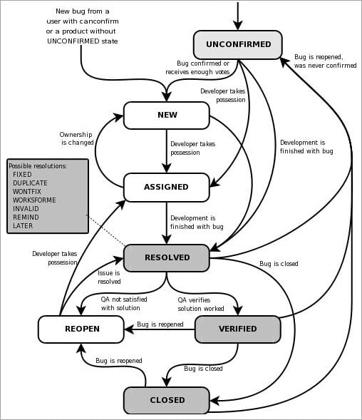](https://cdn.softwaretestinghelp.com/wp-content/qa/uploads/2018/01/Bug-Lifecycle.jpg)

The above image is quite detailed and when you consider the significant steps in Bug Life Cycle you will get a quick idea about it.

On successful logging, the bug is reviewed by the Development or Test manager. The test manager can set the bug status as Open, can Assign the bug to developer or bug may be deferred until the next release.

When a bug gets assigned to a developer and he/she can start working on it. The developer can set the bug status as won’t fix, Couldn’t reproduce, Need more information, or ‘Fixed’.

If the bug status set by the developer is either ‘Need more info’ or Fixed then the QA responds with a specific action. If the bug is fixed then QA verifies the bug and can set the bug status as verified closed or Reopen.

NFRs:

1. Security: Authentication and authorization
2. Localization
3. Usability
4. ARIA
5. Multi device support
6. Multi browser support